Exercise 6: Cursors

BY: Shubham Sangram Bej

Aim
To implement explicit cursors in PL/SQL for retrieving and processing multiple records from the database. The exercise demonstrates the use of cursors to generate customer statements, deduct annual maintenance fees, and update loan interest rates.

Scenario 1: Generate Monthly Statements

Problem Statement
Generate monthly statements for all customers. Write a PL/SQL block using an explicit cursor GenerateMonthlyStatements, that retrieves all transactions for the current month and prints a statement for each customer.

Algorithm
- Declare an explicit cursor to retrieve monthly transactions.
- Open the cursor.
- Fetch one record at a time.
- Display customer and transaction details.
- Continue until all records are processed.
- Close the cursor.

Program
DECLARE
CURSOR MONTHLY_TRANSACTIONS IS
SELECT
C.CUSTOMERID,
C.NAME,
T.TRANSACTIONDATE,
T.TRANSACTIONTYPE,
T.AMOUNT
FROM
CUSTOMERS C
JOIN ACCOUNTS A ON C.CUSTOMERID = A.CUSTOMERID
JOIN TRANSACTIONS T ON A.ACCOUNTID = T.ACCOUNTID
WHERE
TRUNC(T.TRANSACTIONDATE, 'MM') = TRUNC(SYSDATE, 'MM')
ORDER BY
C.CUSTOMERID;

V_CUSTOMERID CUSTOMERS.CUSTOMERID%TYPE;
V_NAME CUSTOMERS.NAME%TYPE;
V_DATE TRANSACTIONS.TRANSACTIONDATE%TYPE;
V_TYPE TRANSACTIONS.TRANSACTIONTYPE%TYPE;
V_AMOUNT TRANSACTIONS.AMOUNT%TYPE;
BEGIN
OPEN MONTHLY_TRANSACTIONS;
LOOP
FETCH MONTHLY_TRANSACTIONS INTO
V_CUSTOMERID,
V_NAME,
V_DATE,
V_TYPE,
V_AMOUNT;
EXIT WHEN MONTHLY_TRANSACTIONS%NOTFOUND;
DBMS_OUTPUT.PUT_LINE('Customer ID : ' || V_CUSTOMERID);
DBMS_OUTPUT.PUT_LINE('Customer Name : ' || V_NAME);
DBMS_OUTPUT.PUT_LINE('Transaction : ' || V_TYPE);
DBMS_OUTPUT.PUT_LINE('Amount : ' || V_AMOUNT);
DBMS_OUTPUT.PUT_LINE('Date : ' || TO_CHAR(V_DATE, 'DD-MON-YYYY'));
DBMS_OUTPUT.PUT_LINE('-----------------------------------');
END LOOP;

CLOSE MONTHLY_TRANSACTIONS;
END;
/

Verifying:
SELECT
C.CUSTOMERID,
C.NAME,
T.TRANSACTIONDATE,
T.TRANSACTIONTYPE,
T.AMOUNT
FROM
CUSTOMERS C
JOIN ACCOUNTS A ON C.CUSTOMERID = A.CUSTOMERID
JOIN TRANSACTIONS T ON A.ACCOUNTID = T.ACCOUNTID
WHERE
TRUNC(T.TRANSACTIONDATE, 'MM') = TRUNC(SYSDATE, 'MM')
ORDER BY
C.CUSTOMERID;

Output
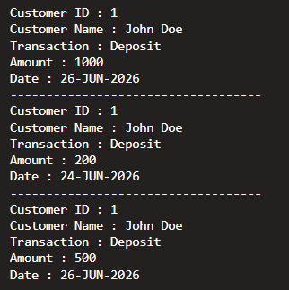

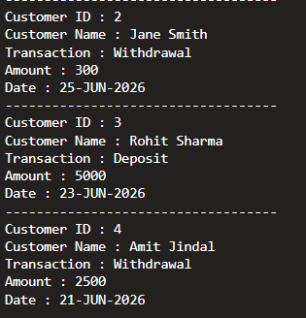

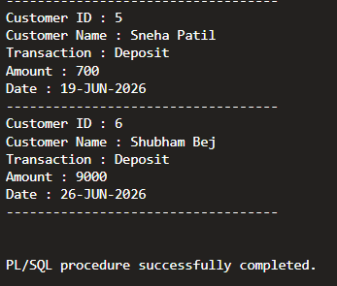

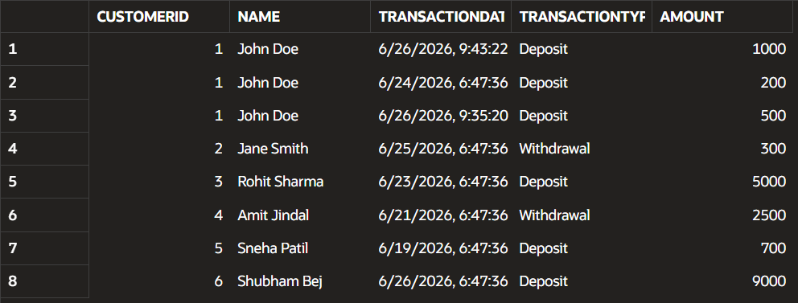

Scenario 2: Apply Annual Fee

Problem Statement
Apply annual fee to all accounts. Write a PL/SQL block using an explicit cursor ApplyAnnualFee that deducts an annual maintenance fee from the balance of all accounts.

Algorithm
- Declare a cursor to fetch all account records.
- Open the cursor.
- Fetch each account.
- Deduct the annual maintenance fee.
- Update the account balance.
- Display the updated balance.
- Commit the changes.
- Close the cursor.

Program

( The balance in AccountID-1 was set to 1500 before running this because subtracting 250 from 205 ( the actual balance of AccountID-1 ) would have resulted in a negative balance that is not acceptable. )
DECLARE
CURSOR ACCOUNT_CURSOR IS
SELECT
ACCOUNTID,
BALANCE
FROM
ACCOUNTS;

V_ACCOUNT ACCOUNTS.ACCOUNTID%TYPE;
V_BALANCE ACCOUNTS.BALANCE%TYPE;
ANNUAL_FEE CONSTANT NUMBER := 250;
BEGIN
OPEN ACCOUNT_CURSOR;
LOOP
FETCH ACCOUNT_CURSOR INTO
V_ACCOUNT,
V_BALANCE;
EXIT WHEN ACCOUNT_CURSOR%NOTFOUND;
UPDATE ACCOUNTS
SET
BALANCE = BALANCE - ANNUAL_FEE
WHERE
ACCOUNTID = V_ACCOUNT;

DBMS_OUTPUT.PUT_LINE('Account '
|| V_ACCOUNT
|| ' updated. New Balance = ' ||(V_BALANCE - ANNUAL_FEE));

END LOOP;

CLOSE ACCOUNT_CURSOR;
COMMIT;
END;
/

Verifying:
SELECT
*
FROM
ACCOUNTS;

Output
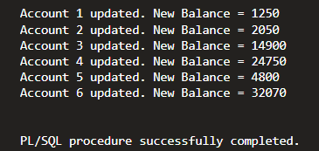

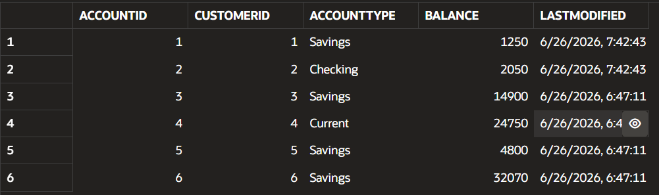

Scenario 3: Update Loan Interest Rates

Problem Statement
Update the interest rate for all loans based on a new policy. Write a PL/SQL block using an explicit cursor UpdateLoanInterestRates, that fetches all loans and updates their interest rates based on the new policy.

Algorithm
- Declare a cursor to fetch all loan records.
- Open the cursor.
- Retrieve each loan.
- Update the interest rate according to the new policy.
- Display the updated interest rate.
- Commit the changes.
- Close the cursor.

Program
DECLARE
CURSOR LOAN_CURSOR IS
SELECT
LOANID,
INTERESTRATE
FROM
LOANS;

V_LOAN LOANS.LOANID%TYPE;
V_RATE LOANS.INTERESTRATE%TYPE;
BEGIN
OPEN LOAN_CURSOR;
LOOP
FETCH LOAN_CURSOR INTO
V_LOAN,
V_RATE;
EXIT WHEN LOAN_CURSOR%NOTFOUND;
UPDATE LOANS
SET
INTERESTRATE = INTERESTRATE + 0.75
WHERE
LOANID = V_LOAN;

DBMS_OUTPUT.PUT_LINE('Loan '
|| V_LOAN
|| ' updated to '
||(V_RATE + 0.75) || '%');

END LOOP;

CLOSE LOAN_CURSOR;
COMMIT;
END;
/

Verifying:
SELECT
LOANID,
INTERESTRATE
FROM
LOANS
ORDER BY
LOANID;

Output
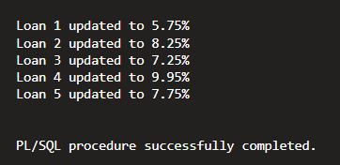

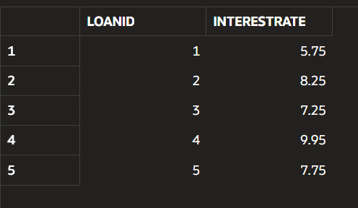

Conclusion
This exercise demonstrated the use of explicit cursors in PL/SQL to process multiple database records sequentially. Cursors were used to generate monthly customer statements, deduct annual maintenance fees from accounts, and update loan interest rates efficiently. Explicit cursors provide greater control over record processing and are useful when handling row-by-row operations in database applications.

